Chiara Adjoh-Davoh
Glenwood Elam
CSCI 354

Project 1 Reflection

I learned quite a bit about pointers while completing this project. To begin, I needed quite a few refreshers on syntax and how pointers can be initialized and dereferenced. Even though I was familiar with pointers beforehand, I had never come across smart pointers before, so that was entirely new to me. I had to spend quite a bit of time looking up the documentation for how to declare and use them. Smart pointers are a great safety measure because they prevent memory overflow. When using regular, low-level pointers, if pointers aren’t deleted after they’re used, they continue to occupy space in the memory. This can lead to a situation where all of the memory gets used up and our code returns an error. To avoid this, smart pointers automatically deallocate memory once a pointer goes out of scope and is no longer of use. This makes our jobs as programmers easier and less stressful.
Over the course of this project, I messed up the syntax a lot. Sometimes, the difference between a pointer and a dereferenced (*) pointer tripped me up, and I would get errors where the code couldn’t be compiled because I was using the asterisk in the wrong place. Other times, I would forget whether or not I needed an asterisk to display certain information, for example, showing the address of a pointer versus the value of what it’s pointing to. Overall though, I think I came into this project with a good grasp on pointers and left it feeling even more confident.

Pointers_basics.cpp
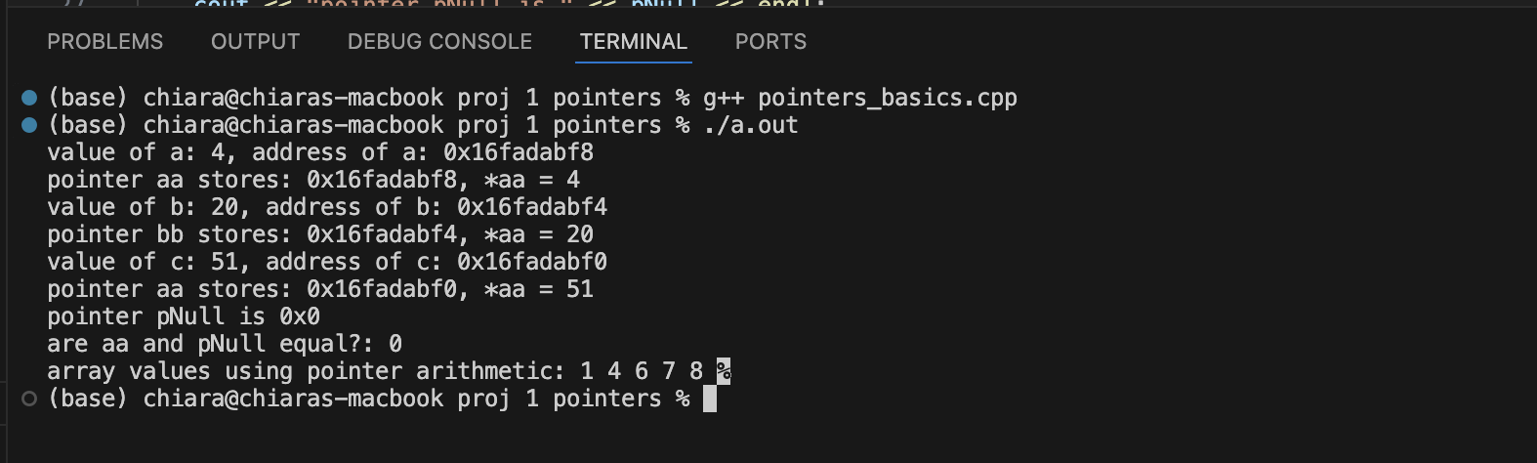

Dynamic_array.cpp
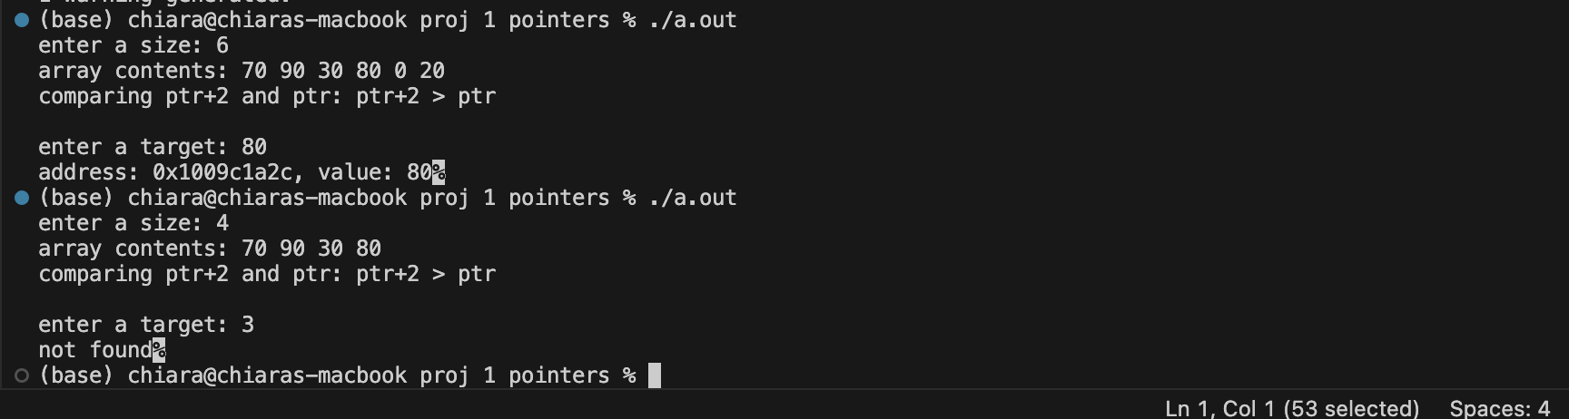

Smart_pointers.cpp
